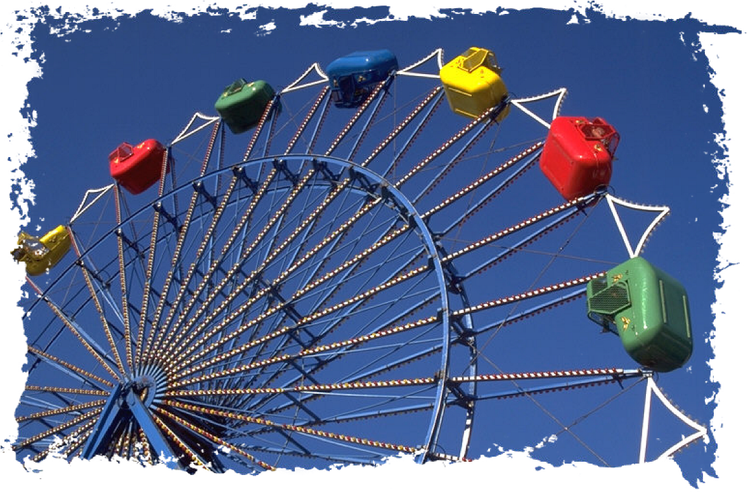
Wheel of Life Exercise
Having a balance in life is important because we can be more content and more alive and enjoy what we are doing. The wheel of life exercise allows you to determine whether you are focusing too much on one part of your life and so neglecting others. The wheel is divided into sections which allow you to rank your level of satisfaction with each area of your life.
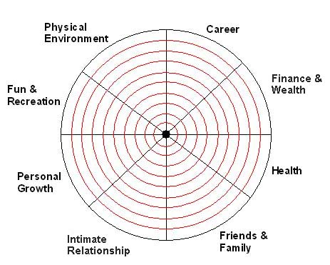
Directions:
The eight sections in the Wheel of Life represent balance. The centre of the wheel represents 0 and the outer edge is 10. Rank your level of satisfaction with each life area, then shade in the appropriate number of sections. For example, if you rank your satisfaction with your career as 5, shade in 5 sections of the career part of the wheel. Once you have shaded each section, you will have created your own wheel of life. If you now view this as a wheel on which your life is running, how bumpy would this ride be if this were a real wheel?
Your result shows you the degree to which you are satisfied with the level of balance in your life. The more shading there is, the more you are satisfied. Which are your low spots – the areas you are least satisfied with? Make a list of them and rank them in order of importance to you right now. If you need help in making some changes, give us a call.
RANKING | LIFE AREA

